Task 14
Code Build created

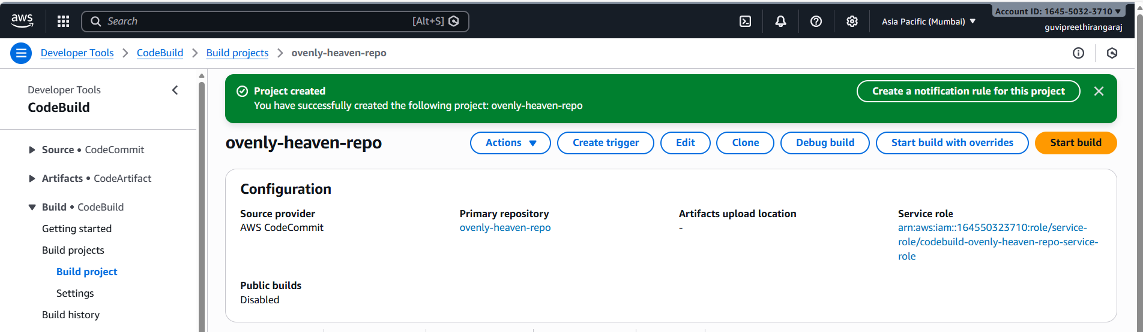

Code Deploy created
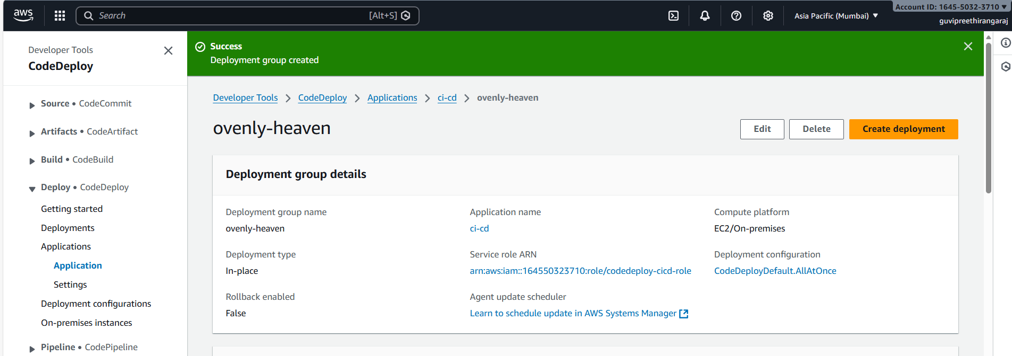

AWS CI/CD Pipeline created
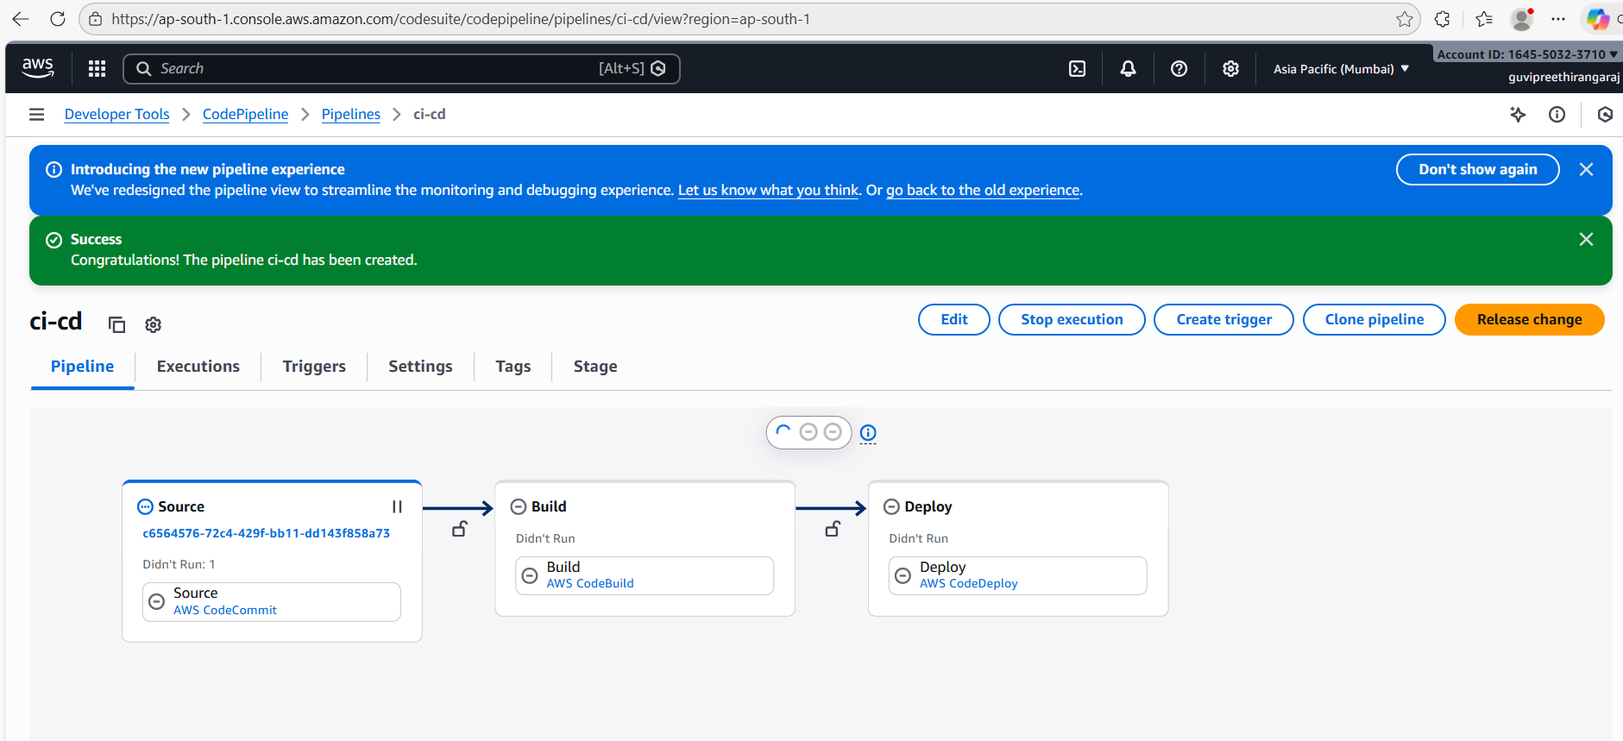

Pipeline completed successfully
